1. Project Title - Amazon Fresh Analytics
Retail Data Management and Business Insights Using SQL
Problem Statement:
Amazon Fresh is an e-commerce platform specializing in groceries and daily essentials. As the platform expands, its management seeks to optimize operations, enhance customer satisfaction, and boost revenue. The challenge lies in effectively managing large volumes of data, including customer profiles, product inventories, supplier information, orders, and customer reviews.
The problem is to design a relational database for Amazon Fresh that organizes this data efficiently, allows for meaningful analysis, and supports critical business decisions. This project aims to solve key business problems, such as identifying top-performing products, analyzing customer purchasing patterns, and ensuring inventory management aligns with demand trends.
Business Use Cases:
- Customer Insights: Analyze purchasing patterns to identify top customers and cities for targeted marketing.
- Product Management: Monitor product demand, stock levels, and performance of product categories.
- Supplier Analysis: Identify key suppliers and optimize supply chain operations.
- Revenue Analysis: Generate revenue trends and identify high-performing regions or categories.
- Customer Satisfaction: Use review data to enhance product offerings and improve customer experience.

Create an ER diagram for the Amazon Fresh database to understand the relationships between tables (e.g., Customers, Products, Orders).
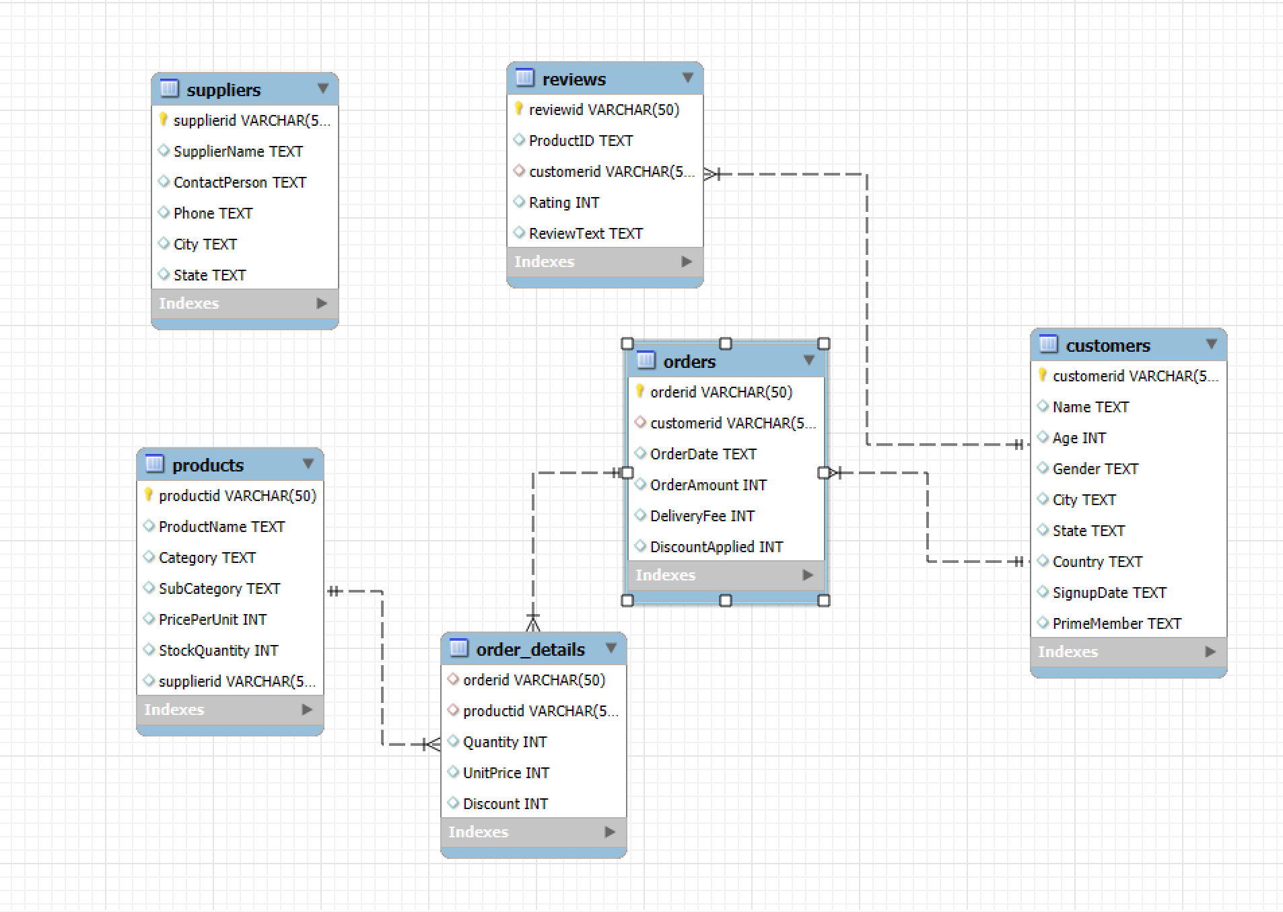

Identify the primary keys and foreign keys for each table and describe their relationships.
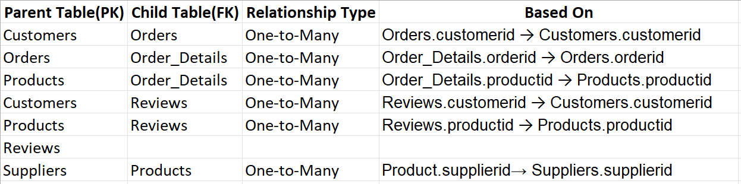

Write a query to:
- Retrieve all customers from a specific city.
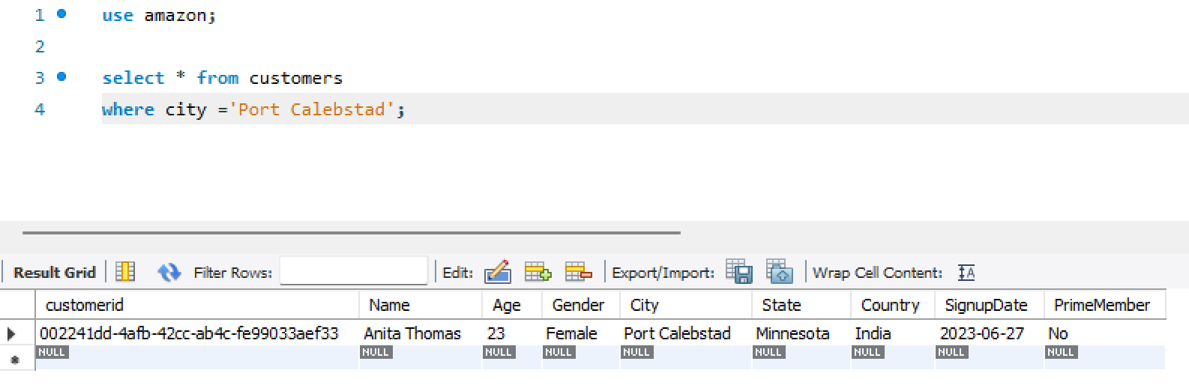
- Fetch all products under the "Fruits" category.
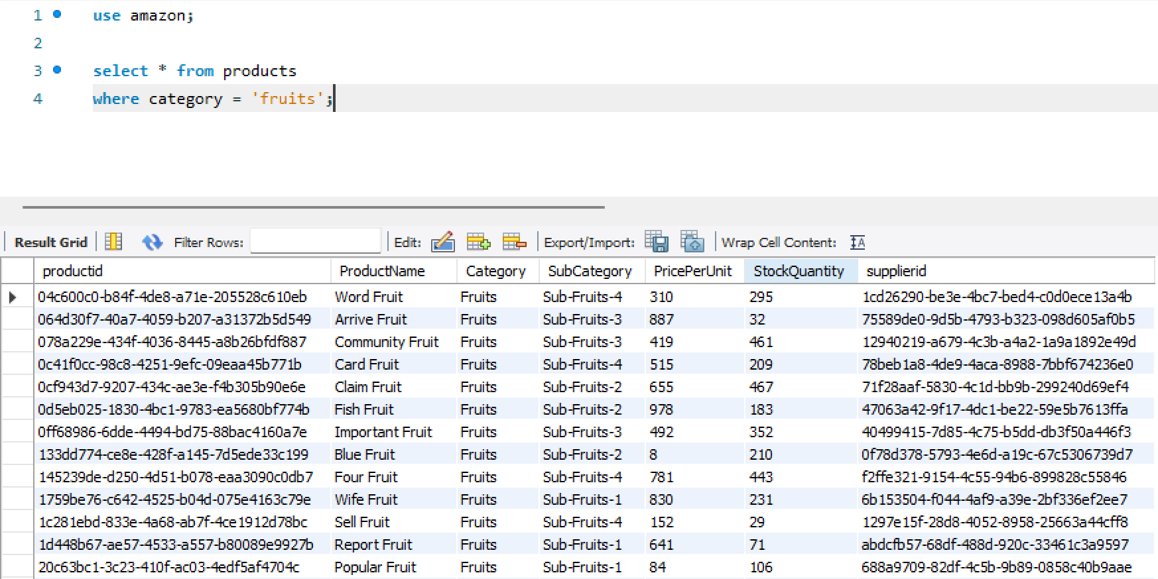

Data Definition Language (DDL) and Constraints
Write DDL statements to recreate the Customers table with the following constraints:
- CustomerID as the primary key.
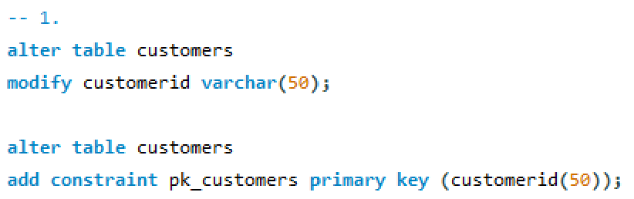
- Ensure Age cannot be null and must be greater than 18.
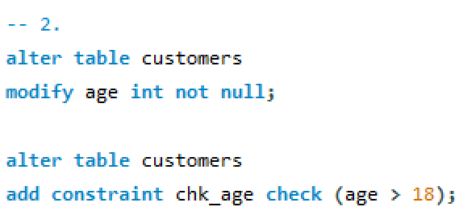
- Add a unique constraint for Name.
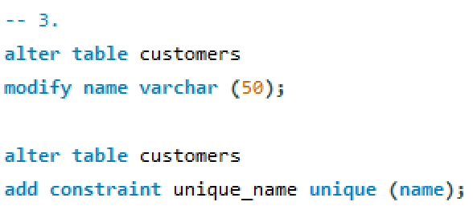

Data Manipulation Language (DML)
Insert 3 new rows into the Products table using INSERT statements.
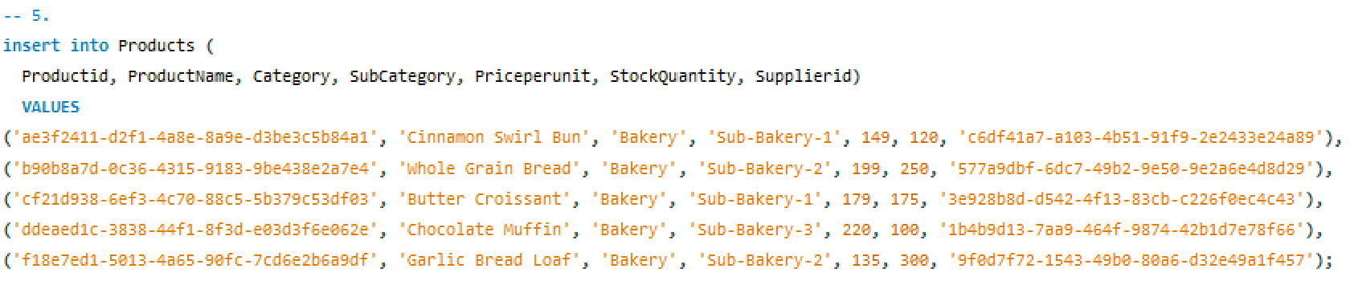

Update the stock quantity of a product where ProductID matches a specific ID.
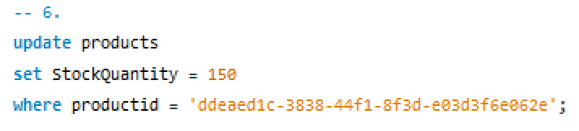
Delete a supplier from the Suppliers table where their city matches a specific value.
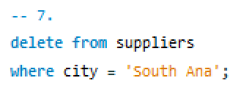

SQL Constraints and Operators
Task 8: Use SQL constraints to:
- Add a CHECK constraint to ensure that ratings in the Reviews table are between 1 and 5.
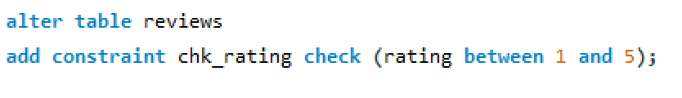
- Add a DEFAULT constraint for the PrimeMember column in the Customers table (default value: "No").
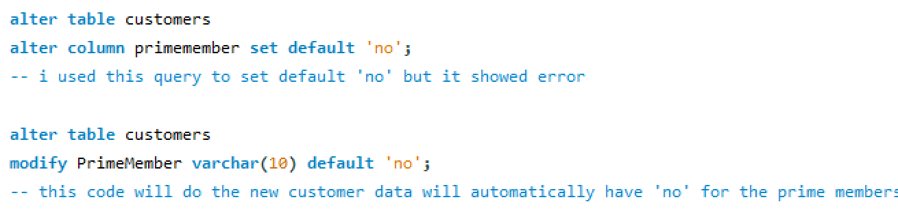

Clauses and Aggregations
Write queries using:
- WHERE clause to find orders placed after 2024-01-01.
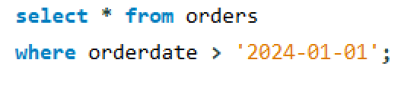
- HAVING clause to list products with average ratings greater than 4.
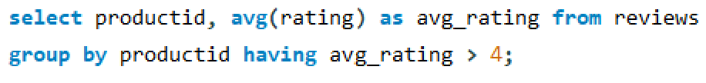

- GROUP BY and ORDER BY clauses to rank products by total sales.
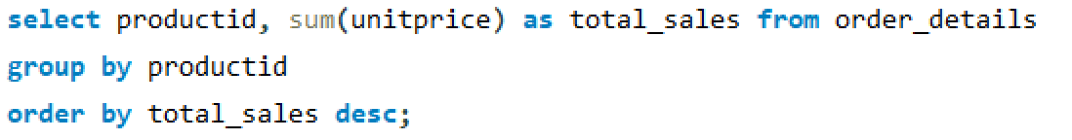

Identifying High-Value Customers

Scenario:

Amazon Fresh wants to identify top customers based on their total spending. We will:

Calculate each customer's total spending.
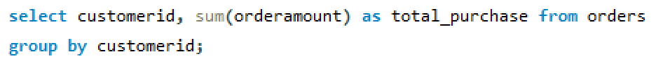

Rank customers based on their spending.
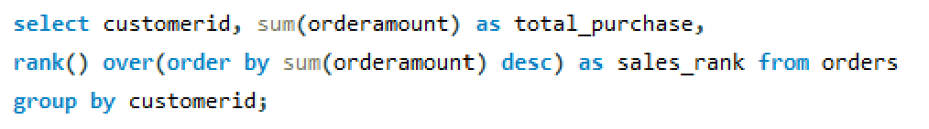

Identify customers who have spent more than ₹5,000.
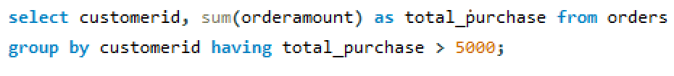

Complex Aggregations and Joins
Use SQL to:
- Join the Orders and OrderDetails tables to calculate total revenue per order.
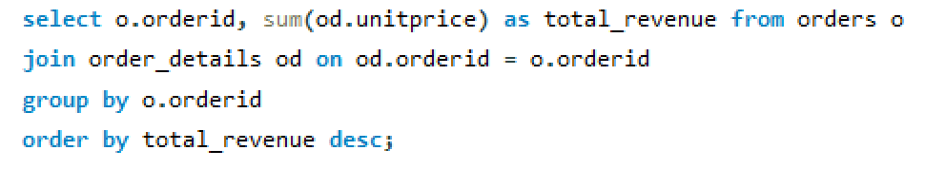
- Identify customers who placed the most orders in a specific time period.
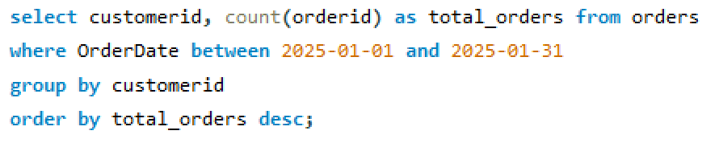
- Find the supplier with the most products in stock.
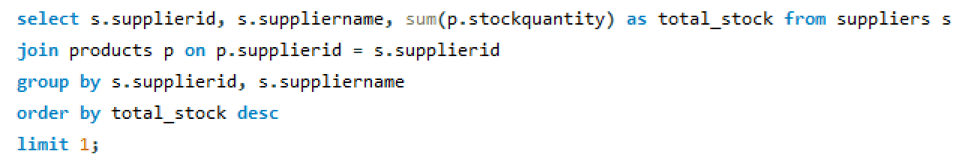

Normalization
Normalize the Products table to 3NF:
- Separate product categories and subcategories into a new table.
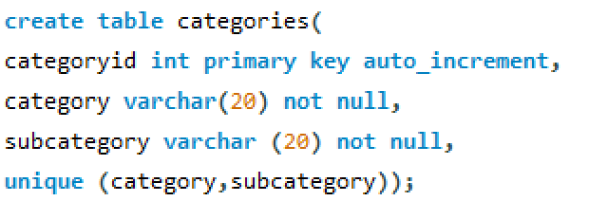

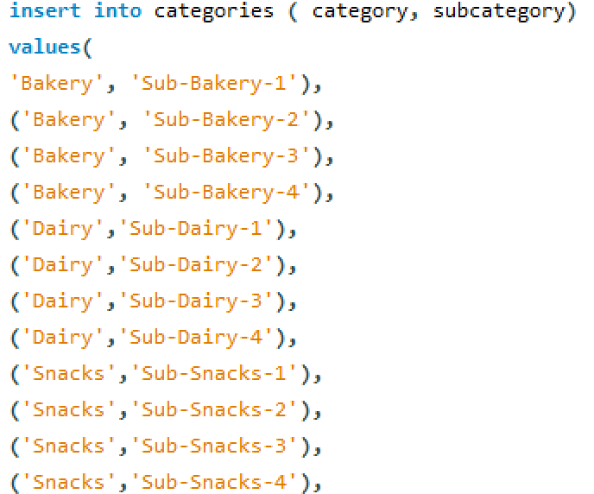

- Create foreign keys to maintain relationships.
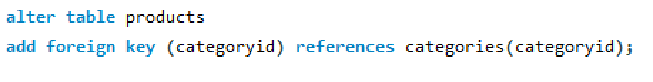

Subqueries and Nested Queries
Write a subquery to:
- Identify the top 3 products based on sales revenue.
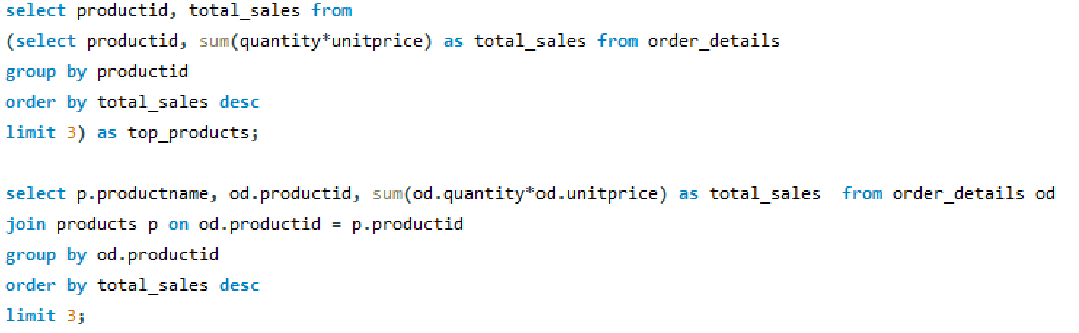

- Find customers who haven’t placed any orders yet.
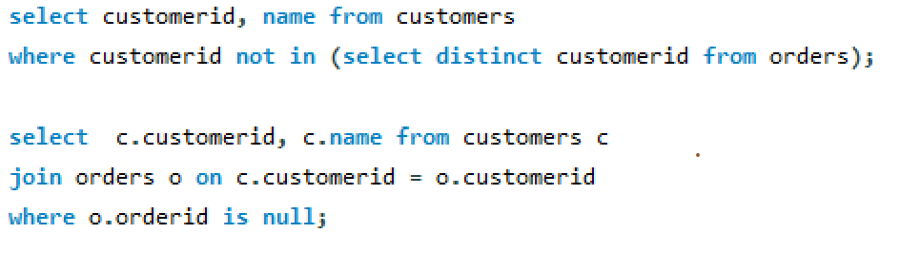

Real-World Analysis
Provide actionable insights:
- Which cities have the highest concentration of Prime members?
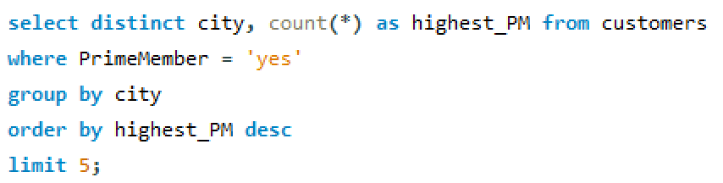
- What are the top 3 most frequently ordered categories?
